Astrobiologist
Astrobiologists study life in the universe: how it began, where it ’s located and how it has evolved or changed over time.

Three main questions drive their research: How did life begin and evolve? Is there life elsewhere in the universe? What is the future for life on Earth and beyond? Astrobiologists need to understand how many different kinds of science work together.

Meet Kennda Lynch, Engineer and Astrobiologist
Job Title: Project Engineer at NASA’s Johnson Space center.
Current Project: Kennda is the Modular Assay for Solar System Exploration (MASSE) project engineer. MASSE is an instrument being developed by NASA to use biotechnology and biochemical assays to test for life on planetary exploration missions.
“We’re looking for evidence of life previously existing on Mars. One fossilized molecule that we’ve found is called a hopane. These little hopane molecules have been proven to survive up to 2.7 billion years. “ Kennda is working to develop an instrument to detect hopane on Mars.
Planetary Geologist
Geology is the study of the solid earth, its rocks and minerals. More than just naming rocks and digging up fossilized bones, geologists tell us the story of the earth. Planetary geologists extend our knowledge of the earth’s geology to interpret the geology of planets, or by studying the geology of planets they better understand the geology of Earth.

Meet Nathalie Cabrol, Planetary Geologist
Job Title: Principal Scientist at NASA Ames
Explanation: At Ames Nathalie researches aqueous (Water) environments favorable to life on Mars, helps with NASA’s exploration of Mars, and works at places on Earth that are similar to Mars. “I am a planetary geologist specializing on Mars exploration, “ she says. “my main domains of research are centered on (1) the evolution of water on Mars, (2) the development of science exploration strategies for planetary missions to the Red Planet, and (3) the exploration of terrestrial analogues to past Martian aqueous environments.” By “analogues,” Nathelie means the places on Earth that are similar to certain places on Mars, for example, a dry valley in Antarctica.

Artist
Artists create art to communicate ideas, thoughts, or feelings. They use a variety of methods—painting, sculpting, or illustration—and an assortment of materials, including oils, watercolors, acrylics, pastels, pencils, pen and ink, plaster, clay, and computers. Artists' works may be realistic, stylized, or abstract and may depict objects, people, nature, or events.

Meet Lynette Cook, Space Artist
Job Title: Freelance artist
Explanation: Space artists take the images and scientific facts about a space subject (galaxy, nebula, planet, etc), and imagine what it would look like if you were able to see it up close. They then paint or draw what they see in their mind’s eye. This way they can teach people what astronomers are learning and provide a better understanding. As Lynette describes it, “I create illustrations for use in publications, which explain visually the scientific research in astronomy being conducted today.”

Astrophysicist
Astrophysicists study objects in the universe including galaxies and stars to understand what they are made of, their surface features, their histories and how they were formed. To study these bodies, astrophysicists often come up with new tools and ways to investigate them.

Meet Kimberly Ennico, Astrophysicist
Explanation: As an astrophysicist, Kimberly works with others to develop new instruments and techniques to make sure that new hardware will return better scientific data.
“My current job at NASA,” explains Kimberly, involves developing novel instrumentation techniques in support of current and future ground, airborne, and space-based astronomical infrared telescopes and their supporting instruments (e.g., cameras/ spectrometers). I also test the performance of infrared detectors and investigate the effect of space radiation on such detectors.” (One use of Infrared detectors is to measure the heat that an object releases.)

Writer
Writers communicate through the written word. Writers generally fall into one of two categories. Writers and authors develop original fiction and nonfiction for books, magazines and trade journals, newspapers, radio and television broadcasts, motion pictures, and advertisements. Technical writers develop scientific or technical materials.

Meet Kye Ewing, Writer, Educator
Job: Author of several children’s activity books.
Explanation: By mixing astronomy and space into the puzzle and activity books she writes, Kye helps children have more fun with mathematics. Some of the activities in Kye’s books include packing for an imaginary trip in space and using “wayfinding” techniques to chart a course through a place like a schoolyard.

Meet Lisa Doyle, Technical Writer
“I write manuals for how to operate (and fix) the wind tunnels here at Ames. I also write other important documents that must be kept up to date so that all the work we do is recorded for future reference.”

Communication Specialist
Informing the general public, and interest groups of an organization's activities and accomplishments is an important part of a communications specialist's job.
Communications (also known as public relations) specialists prepare press releases and contact people in the media who might print or broadcast their material.

Meet Lisa Malone
Job Title: Chief of the Media Services Branch at NASA's John F. Kennedy Space Center
Explanation: Lisa’s responsibilities include managing media activities surrounding launches, landings, astronaut activities and other high profile events. Lisa is responsible for all printed information, video releases, news conferences, official still photography and production of live coverage of KSC launches, landings and press conferences. She oversees activities of various motion picture and television crews which shoot film footage to create NASA-KSC related feature films, documentaries and news shows with diverse audiences. She serves as launch commentator for Space Shuttle launches, as a spokeswoman for KSC; and coordinates and moderates news conferences.

Mechanical Engineer
Mechanical engineers plan and design engines, machines and other equipment. When designing a new product, engineers first figure out what it needs to do. They then design and test the parts, fit the parts together and test to see how successful it is.

Meet Tina Herrera
“I am a mechanical engineer. I worked in a biomechanics research laboratory conducting studies and experiments as well as designing and developing test equipment until a year and a half ago. I'm now working in the Life Science Payloads office managing the development of life sciences experiments that fly on the shuttle and space station. One of the most exciting things about my job here is to be involved with cutting edge research and projects that are unique to NASA but valuable to all of humankind. I feel fortunate to be surrounded by so many brilliant scientists. It's really fantastic to work in a place that pushes the envelope of our knowledge and understanding.”

Mathematician, Computer Engineer
Theoretical mathematicians come up with new mathematical rules and processes using the latest technology. Applied mathematicians use math rules and processes to solve scientific, engineering and business problems. Computer engineers design and develop computers or robots. When designing a new product, engineers first figure out what it needs to do. They then design and test the parts, fit the parts together and test to see how successful it is.

Meet Kim Hubbard, Computer Engineer
“One interesting project I worked on in the past, was the Wireless Network Experiment (WNE). It was performed on both the Space Shuttle Atlantis and the Russian Mir Space Station in March 1996 during the STS-76 mission. Using three computers, astronauts operated the first wireless local area network in space. The WNE was designed to evaluate electromagnetic compatibility, computer performance, wireless network performance and human factors issues. This experiment is part of a larger program to provide a reliable, flexible network infrastructure for the International Space Station (ISS) that will support astronauts in performing experiments and other tasks aboard the ISS.“

Cool Careers on the Final Frontier  Laura Woodmansee writes:  “In the future, new jobs will be created that we can’t even dream of today. Your best bet is to find the area or subject that interests you most, and then do your best.”  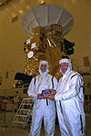  “Engineer and Astrobiologist Kennda Lynch encourages girls to get involved in the Girl Scouts; ‘It was a very good experience,’ she says. ‘It taught me empowerment as a young lady. I gained self-esteem, self-assurance, and I learned what the power of my actions could do. And I learned what the world was like because I was able to travel so much as a Girl Scout.’“  The career descriptions and mini-biographies on these cards are taken from the following sources:  Women of Space: Cool Careers on the Final Frontier  by Laura S. Woodmansee  U.S. Department of Labor, Bureau of Labor Statistics Occupational Outlook Handbook, http://www.bls.gov/  NASA Quest, Women of NASA, http://www.quest.arc.nasa.gov/women/intro.html  NASA, AstroVenture, http://astroventure.arc.nasa.gov/avhome.html | Cool Careers on the Final Frontier  Laura Woodmansee writes:  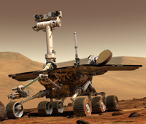  “In the future, new jobs will be created that we can’t even dream of today. Your best bet is to find the area or subject that interests you most, and then do your best.”  “Engineer and Astrobiologist Kennda Lynch encourages girls to get involved in the Girl Scouts; ‘It was a very good experience,’ she says. ‘It taught me empowerment as a young lady. I gained self-esteem, self-assurance, and I learned what the power of my actions could do. And I learned what the world was like because I was able to travel so much as a Girl Scout.’“  The career descriptions and mini-biographies on these cards are taken from the following sources:  Women of Space: Cool Careers on the Final Frontier  by Laura S. Woodmansee  U.S. Department of Labor, Bureau of Labor Statistics Occupational Outlook Handbook, http://www.bls.gov/  NASA Quest, Women of NASA, http://www.quest.arc.nasa.gov/women/intro.html  NASA, AstroVenture, http://astroventure.arc.nasa.gov/avhome.html
Cool Careers on the Final Frontier  Laura Woodmansee writes:  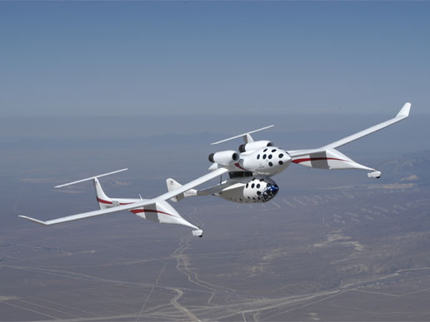  “In the future, new jobs will be created that we can’t even dream of today. Your best bet is to find the area or subject that interests you most, and then do your best.”  “Engineer and Astrobiologist Kennda Lynch encourages girls to get involved in the Girl Scouts; ‘It was a very good experience,’ she says. ‘It taught me empowerment as a young lady. I gained self-esteem, self-assurance, and I learned what the power of my actions could do. And I learned what the world was like because I was able to travel so much as a Girl Scout.’“  The career descriptions and mini-biographies on these cards are taken from the following sources:  Women of Space: Cool Careers on the Final Frontier  by Laura S. Woodmansee  U.S. Department of Labor, Bureau of Labor Statistics Occupational Outlook Handbook, http://www.bls.gov/  NASA Quest, Women of NASA, http://www.quest.arc.nasa.gov/women/intro.html  NASA, AstroVenture, http://astroventure.arc.nasa.gov/avhome.html | Cool Careers on the Final Frontier  Laura Woodmansee writes:  “In the future, new jobs will be created that we can’t even dream of today. Your best bet is to find the area or subject that interests you most, and then do your best.”  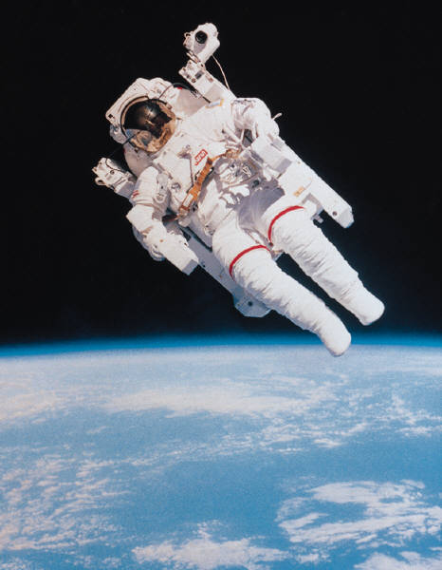  “Engineer and Astrobiologist Kennda Lynch encourages girls to get involved in the Girl Scouts; ‘It was a very good experience,’ she says. ‘It taught me empowerment as a young lady. I gained self-esteem, self-assurance, and I learned what the power of my actions could do. And I learned what the world was like because I was able to travel so much as a Girl Scout.’“  The career descriptions and mini-biographies on these cards are taken from the following sources:  Women of Space: Cool Careers on the Final Frontier  by Laura S. Woodmansee  U.S. Department of Labor, Bureau of Labor Statistics Occupational Outlook Handbook, http://www.bls.gov/  NASA Quest, Women of NASA, http://www.quest.arc.nasa.gov/women/intro.html  NASA, AstroVenture, http://astroventure.arc.nasa.gov/avhome.html
Cool Careers on the Final Frontier  Laura Woodmansee writes:  “In the future, new jobs will be created that we can’t even dream of today. Your best bet is to find the area or subject that interests you most, and then do your best.”  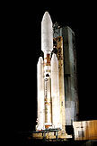  “Engineer and Astrobiologist Kennda Lynch encourages girls to get involved in the Girl Scouts; ‘It was a very good experience,’ she says. ‘It taught me empowerment as a young lady. I gained self-esteem, self-assurance, and I learned what the power of my actions could do. And I learned what the world was like because I was able to travel so much as a Girl Scout.’“  The career descriptions and mini-biographies on these cards are taken from the following sources:  Women of Space: Cool Careers on the Final Frontier  by Laura S. Woodmansee  U.S. Department of Labor, Bureau of Labor Statistics Occupational Outlook Handbook, http://www.bls.gov/  NASA Quest, Women of NASA, http://www.quest.arc.nasa.gov/women/intro.html  NASA, AstroVenture, http://astroventure.arc.nasa.gov/avhome.html | Cool Careers on the Final Frontier  Laura Woodmansee writes:  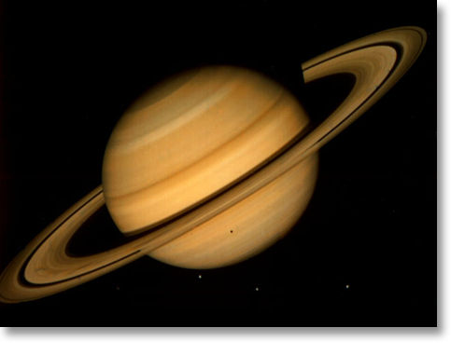  “In the future, new jobs will be created that we can’t even dream of today. Your best bet is to find the area or subject that interests you most, and then do your best.”  “Engineer and Astrobiologist Kennda Lynch encourages girls to get involved in the Girl Scouts; ‘It was a very good experience,’ she says. ‘It taught me empowerment as a young lady. I gained self-esteem, self-assurance, and I learned what the power of my actions could do. And I learned what the world was like because I was able to travel so much as a Girl Scout.’“  The career descriptions and mini-biographies on these cards are taken from the following sources:  Women of Space: Cool Careers on the Final Frontier  by Laura S. Woodmansee  U.S. Department of Labor, Bureau of Labor Statistics Occupational Outlook Handbook, http://www.bls.gov/  NASA Quest, Women of NASA, http://www.quest.arc.nasa.gov/women/intro.html  NASA, AstroVenture, http://astroventure.arc.nasa.gov/avhome.html
Cool Careers on the Final Frontier  Laura Woodmansee writes:  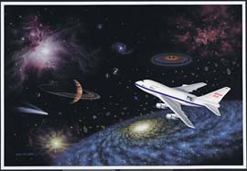  “In the future, new jobs will be created that we can’t even dream of today. Your best bet is to find the area or subject that interests you most, and then do your best.”  “Engineer and Astrobiologist Kennda Lynch encourages girls to get involved in the Girl Scouts; ‘It was a very good experience,’ she says. ‘It taught me empowerment as a young lady. I gained self-esteem, self-assurance, and I learned what the power of my actions could do. And I learned what the world was like because I was able to travel so much as a Girl Scout.’“  The career descriptions and mini-biographies on these cards are taken from the following sources:  Women of Space: Cool Careers on the Final Frontier  by Laura S. Woodmansee  U.S. Department of Labor, Bureau of Labor Statistics Occupational Outlook Handbook, http://www.bls.gov/  NASA Quest, Women of NASA, http://www.quest.arc.nasa.gov/women/intro.html  NASA, AstroVenture, http://astroventure.arc.nasa.gov/avhome.html | Cool Careers on the Final Frontier  Laura Woodmansee writes:  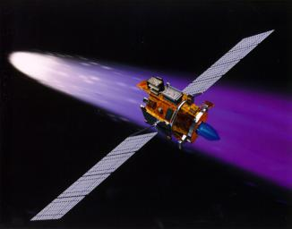  “In the future, new jobs will be created that we can’t even dream of today. Your best bet is to find the area or subject that interests you most, and then do your best.”  “Engineer and Astrobiologist Kennda Lynch encourages girls to get involved in the Girl Scouts; ‘It was a very good experience,’ she says. ‘It taught me empowerment as a young lady. I gained self-esteem, self-assurance, and I learned what the power of my actions could do. And I learned what the world was like because I was able to travel so much as a Girl Scout.’“  The career descriptions and mini-biographies on these cards are taken from the following sources:  Women of Space: Cool Careers on the Final Frontier  by Laura S. Woodmansee  U.S. Department of Labor, Bureau of Labor Statistics Occupational Outlook Handbook, http://www.bls.gov/  NASA Quest, Women of NASA, http://www.quest.arc.nasa.gov/women/intro.html  NASA, AstroVenture, http://astroventure.arc.nasa.gov/avhome.html

